IO pins microcontrollers

PIC

TRIS registers bepalen input of output (1 = input, 0 is output)
PORT registers bepalen de toestand van een output pin, of geven de toestand weer van een input pin

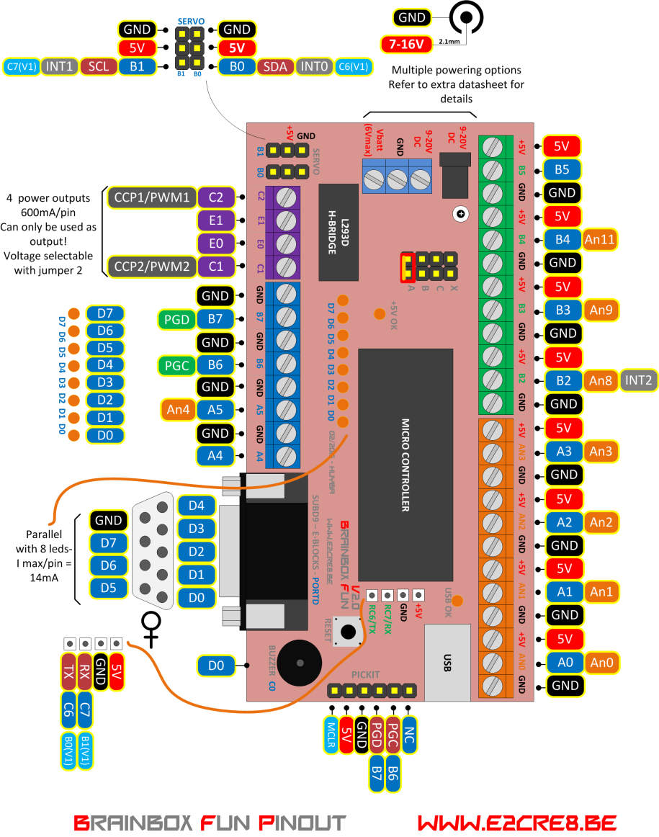

Programma 1 : 8 leds – PORTD – 4MSB en 4LSB flashen alternerend

TRISD – PORTD
Digital output
While(1)
void main(void)
// comment
#include
#define
!!Functie delay 100msec

// PIC18F4455 Configuration Bit Settings -
// all config settings are made in the bootloader

#include <xc.h> // general XC8 library
#define _XTAL_FREQ 48000000 // Brainbox Fun running at 48Mhz

// The delay routine of the XC8 compiler is limited.
// __delay_ms(100); would be too large
// Solution: this function that repeats the 10msec delay 10 times

void delay_10ms(unsigned char n)
{
while (n-- != 0)
{
__delay_ms(10);
}
}

void main(void) // main program
{
TRISD = 0x00; // make all pins of PORTD output pins

while(1) // never ending loop
{
PORTD = 0xF0; // make 4 MSB's of PORTD high
delay_10ms(10); // wait for 100msec (10x10msec))
PORTD = 0x0F; // make 4 LSB's of PORTD high
delay_10ms(10); // wait for 100msec (10x10msec))

}
}

Programma 2: Binaire teller 0-255 op leds aan PORTD

for loop
variables
x=x+1 x++
#define leds PORTD

// PIC18F4455 Configuration Bit Settings -
// all config settings are made in the bootloader

#include <xc.h> // general XC8 library
#define _XTAL_FREQ 48000000 // Brainbox Fun running at 48Mhz
#define leds PORTD // replace leds by PORTD

char x = 0; // declaration of variables

void main(void) // main program
{
TRISD = 0x00; // make all pins of PORTD output pins
while(1)
{
for (x = 0; x < 255 ; x= x + 1) // x is 0 to start; as long as x is smaller than 255; increment x
{
leds = x; // visualise x at leds on PORTD
__delay_ms(10); // wait for 100msec (10x10msec))
}
x = 0; // set x back to 0
}
}

Programma 3 : If then else demo

if elseif else
Output maskers

#include <xc.h> // general XC8 library
#define _XTAL_FREQ 48000000 // Brainbox Fun running at 48Mhz
#define leds PORTD // replace leds by PORTD

char x = 0; // declaration of variables

void delay_10ms(unsigned char n)
{
while (n-- != 0) {
__delay_ms(10);
}
}

void main(void) // main program
{
TRISD = 0x00; // make all pins of PORTD output pins
while(1) // loop zolang x < of gelijk is aan 15
{

while(x <= 15) // loop zolang x < of gelijk is aan 15
{

leds= x; // visualise x at leds on PORTD

if (x < 5) // als x < 5
{
leds = leds | 0b00010000;
// maak RD4 hoog zonder de andere bits te veranderen
}
if (x < 10)
{
leds = leds | 0b00100000;
// maak RD5 hoog zonder de andere bits te veranderen
}
else if (x < 14)
{
leds = leds ^ 0b11110000;
// ^ exor – flip de 4 MSB’s
}
else
{
leds = leds & 0b00001111;
// maak de 4 MSB's laag, zonder iets aan de 4 LSB te veranderen
}

delay_10ms(100); // wait for 500msec (10x10msec))
x = x + 1;
}
}

}

Programma 4 : Case demo

Case

// PIC18F4455 Configuration Bit Settings -
// all config settings are made in the bootloader

#include <xc.h> // general XC8 library
#define _XTAL_FREQ 48000000 // Brainbox Fun running at 48Mhz
#define leds PORTD // replace leds by PORTD

char x = 0; // declaration of variables

void delay_10ms(unsigned char n)
{
while (n-- != 0) {
__delay_ms(10);
}
}

void main(void) // main program
{
TRISD = 0x00; // make all pins of PORTD output pins
while(x <= 5) // loop zolang x < of gelijk is aan 15
{
leds= x; // visualise x at leds on PORTD

switch(x)
{
case 1: // in het geval x gelijk is aan 1
leds = leds | 0b00010000;
// maak RD4 hoog zonder de andere bits te veranderen
break;

case 2: // in het geval x gelijk is aan 2
leds = leds | 0b00100000;
// maak RD5 hoog zonder de andere bits te veranderen
break;

case 3: // in het geval x gelijk is aan 3
leds = leds | 0b01000000;
// maak RD6 hoog zonder de andere bits te veranderen
break;

default: // in alle andere gevallen
leds = leds & 0b00001111;
// maak de 4 MSB's laag, zonder iets aan de 4 LSB te veranderen
break;
}

delay_10ms(100); // wait for 500msec (10x10msec))
x = x + 1;
}
x = 0; // set x back to 0
}

Programma 5 : Wanneer input pin B2 hoog is gaan de leds aan PORTD aan

Digital input
Pic18f4455.h bestand
TRISBbits.RB2
If else
ANSEL (Niet voor 18F)

// PIC18F4455 Configuration Bit Settings -
// all config settings are made in the bootloader

#include <xc.h> // general XC8 library
#define _XTAL_FREQ 48000000 // Brainbox Fun running at 48Mhz

#define INPUTB2 PORTBbits.RB2 // replace INPUTB2 by PORTBbits.RB2 during compilation
#define LEDARRAY PORTD // replace LEDARRAY by PORTD during compilation

void main(void) // main program
{
TRISBbits.RB2 = 1; // make pin INPUT pin
TRISD = 0x00; // make all 8 bits of PORTD output – LEDS
// !!for 16FPIC – Be aware of ANSEL registers

while(1)
{ // never ending loop

if (INPUTB2 == 1) // if input reads as 'high'
{
LEDARRAY = 0xFF; // All leds ON
}
else // if input reads as 'low'
{
LEDARRAY = 0x00; // All leds OFF
}
}
}

Programma 6 : Input maskers

Input maskers
If (TRUE / FALSE)
Bitwise & - Bytewise &&

#include <xc.h> // general XC8 library
#define _XTAL_FREQ 48000000 // Brainbox Fun running at 48Mhz
#define LEDARRAY PORTD // replace LEDARRAY by PORTD during compilation

void main(void) // main program
{
TRISB = TRISB | 0b00010100;
// B4 & B2 input pin without changing other pins
TRISD = 0x00; // make all 8 bits of PORTD output LEDS
// !!for 16FPIC Be aware of ANSEL registers

while(1)
{ // never ending loop

if ((PORTB & 0b00000100) && !(PORTB & 0b00010000))
// if B4 is 1 and B2 is 0
{
LEDARRAY = 0x0F;
}
else if (!(PORTB & 0b00000100) && (PORTB & 0b00010000))
// if B4 is 0 and B2 is 1
{
LEDARRAY = 0xF0;
}
else if ((PORTB & 0b00000100) && (PORTB & 0b00010000))
// if B4 is 0 and B2 is 1
{
LEDARRAY = 0xFF;
}
else
{
LEDARRAY = 0b10000001;
}
}
}

Programma 7 : Functies

Functies types:
- void functie (void) – krijgt geen data mee en geeft geen data terug
- void functie (var) – krijgt data mee, maar geeft geen data terug
- var functie (var) – krijgt data mee en geeft data terug

#include <xc.h> // general XC8 library
#define LEDARRAY PORTD // replace LEDARRAY by PORTD during compilation

char x; // global variable x (can be used all over the program and in every function)

// function prototypes - maak aan de compiler duidelijk dat deze 3 functies bestaan
// deze functies mogen nu na de main loop uitgescheven worden
void increment_x(void);
void delay(unsigned short long w);
int macht(int x, int y);

void main(void) // main program
{
TRISB = TRISB | 0b00000100; // B2 input pin without changing other pins
TRISD = 0x00; // make all 8 bits of PORTD output LEDS

while(1)
{ // never ending loop
if (PORTB & 0b00000100) // als pin RB2 hoog is
{
x = 2; // x = 2
LEDARRAY = x; // visualiseer x op leds = 2
delay (480000); // functie wacht 480000
increment_x(); // functie x = x + 1 -> x is nu dus 3
LEDARRAY = x; // visualiseer x op leds = 3
delay (480000); // functie wacht 480000
x= macht(x,3); // x was 3 - tot 3e macht maakt 27 - x is
//nu dus 27
LEDARRAY = x; // visualiseer x op leds = 27 = 0b00011011
delay (480000); // functie wacht 480000
}
LEDARRAY = 0;
}
}

//***** Functies ***************************
void increment_x(void)
{
x = x + 1; // x = x + 1
}

void delay(unsigned short long w)
{
unsigned short long i = 0; // local variable i - can only be used in this function
for (i = 0; i<w; i++){} // for loop die w maal herhaald zal worden
// door de grote variabelen zal dit toch enige tijd duren
}

int macht(int x, int y)
{
int i, m; // declaration of 2 local variables
int a = x; // stel a gelijk aan grondtal x
for (i=1; i<y; i++) // herhaal zolang de exponent niet bereikt is
{
m=(a*x);
a=m;
}
return m; // geef de uitkomst terug aan het programma nadat de functie is volbracht
}

Programma 8 : functies in c en h files

Functies en functie prototypes kunnen ook in afzonderlijke bestanden gezet worden zodat ze door meerdere programma’s kunnen worden gebruikt.

#include <xc.h> // general XC8 library
#include "E2CRE8.h" // general XC8 library

#define _XTAL_FREQ 48000000 // Brainbox Fun running at 48Mhz
#define LEDARRAY PORTD // replace LEDARRAY by PORTD during compilation

char x; // global variable x (can be used all over the program and in every function)

void main(void) // main program
{
TRISB = TRISB | 0b00000100; // B2 input pin without changing other pins
TRISD = 0x00; // make all 8 bits of PORTD output LEDS

while(1)
{ // never ending loop
if (PORTB & 0b00000100) // als pin RB2 hoog is
{
x = 2; // x = 2
LEDARRAY = x; // visualiseer x op leds = 2
delay (480000); // functie wacht 480000
increment_x(); // functie x = x + 1 -> x is nu dus 3
LEDARRAY = x; // visualiseer x op leds = 3
delay (480000); // functie wacht 480000
x= macht(x,3); // x was 3 - tot 3e macht maakt 27 - x is nu dus 27
LEDARRAY = x; // visualiseer x op leds = 27 = 0b00011011
delay (480000); // functie wacht 480000
}
LEDARRAY = 0;
}
}

E2CRE8.h
#include <xc.h> // include processor files - each processor file is guarded.

void increment_x(void);
void delay(unsigned short long w);
int macht(int x, int y);

E2CRE8.c
#include <xc.h> // general XC8 library
#define _XTAL_FREQ 48000000 // Brainbox Fun running at 48Mhz

char x; // global variable x (can be used all over the program and in every function)

//***** Functies ***************************
void increment_x(void)
{
x = x + 1; // x = x + 1
}

void delay(unsigned short long w)
{
unsigned short long i = 0; // local variable i - can only be used in this function
for (i = 0; i<w; i++){} // for loop die w maal herhaald zal worden
// door de grote variabelen zal dit toch enige tijd duren
}

int macht(int x, int y)
{
int i, m; // declaration of 2 local variables
int a = x; // stel a gelijk aan grondtal x
for (i=1; i<y; i++) // herhaal zolang de exponent niet bereikt is
{
m=(a*x);
a=m;
}
return m; // geef de uitkomst terug aan het programma nadat de functie is volbracht
}

AD conversie

PIC 18F4455 (Brainbox Fun)

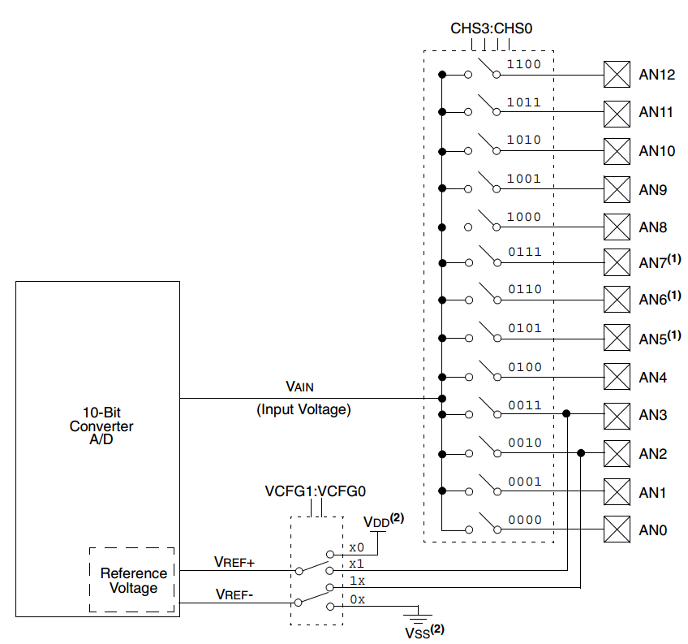

Programma 9: AD conversie

AD convertor registers

/*This program 'reads' the analog voltage at pin AN0
* The 8 bit result is displayed at the 8 leds of PORTD
* Connect a potmeter to AN0 (between 5V and GND)*/
// PIC18F4455 Configuration Bit Settings -
// all config settings are made in the bootloader

#include <xc.h> // general XC8 library
#define _XTAL_FREQ 48000000 // Brainbox Fun running at 48Mhz

#define LEDARRAY PORTD // using a define to give pin a better name

void main(void) // main program
{
//alle these settings are well explained in the datasheet of the 18F4455
TRISD = 0x00; // make all 8 bits of PORTD output - LEDS

TRISAbits.RA0 = 1; // make pin INPUT pin
TRISAbits.RA1 = 1; // make pin INPUT pin
TRISAbits.RA2 = 1; // make pin INPUT pin
TRISAbits.RA3 = 1; // make pin INPUT pin

ADCON2bits.ADFM = 0; // 0 = Left justified -> 8 bit adc
ADCON2bits.ACQT2 = 1;
ADCON2bits.ACQT1 = 1;
ADCON2bits.ACQT0 = 1; // 111 = Aquisition time of 20 TAD - slowest
ADCON2bits.ADCS2 = 1;
ADCON2bits.ADCS2 = 1;
ADCON2bits.ADCS2 = 1; // FOSC/64 is necessary for 48Mhz clock

ADCON1bits.VCFG1 = 0; // REF- = VSS
ADCON1bits.VCFG0 = 0; // REF+ = VDD
ADCON1bits.PCFG3 = 1;
ADCON1bits.PCFG2 = 0;
ADCON1bits.PCFG1 = 1;
ADCON1bits.PCFG0 = 1; //1011 makes AN0, AN1, AN2, AN3 all AD pins
// all other AD pins are normal digital IO pins

ADCON0bits.CHS3 = 0;
ADCON0bits.CHS2 = 0;
ADCON0bits.CHS1 = 0;
ADCON0bits.CHS0 = 0; // 0000 = Select Channel AN0 for AD conversion
ADCON0bits.ADON = 1; // switch AD convertor on

while(1)
{ // never ending loop
ADCON0bits.GODONE = 1; // Start AD conversion
while (GODONE){} // wait for AD conversion to complete
LEDARRAY = ADRESH; // show 8 bit AD result on LEDS of portD
}
}

Programma 10: gebruik van arrays – gemiddelde van metingen

Arrays zijn een ideale manier om data in verschillende cellen het ram geheugen als groep aan te spreken.
Met dit programma demonstreren we een “moving average window” filter die steeds het gemiddelde van de laatste 10 metingen weergeeft.

#include <xc.h> // general XC8 library
#define _XTAL_FREQ 48000000 // Brainbox Fun running at 48Mhz
#define LEDARRAY PORTD // using a define to give pin a better name
#define samples 10

char avg[samples] = {0,0,0,0,0,0,0,0,0,0};
int total = 0;
int average = 0;

void delay_10ms(unsigned char n)
{
while (n-- != 0)
{
__delay_ms(10);
}
}

void main(void) // main program
{
//alle these settings are well explained in the datasheet of the 18F4455
TRISD = 0x00; // make all 8 bits of PORTD output - LEDS

TRISAbits.RA0 = 1; // make pin INPUT pin
TRISAbits.RA1 = 1; // make pin INPUT pin
TRISAbits.RA2 = 1; // make pin INPUT pin
TRISAbits.RA3 = 1; // make pin INPUT pin

ADCON2bits.ADFM = 0; // 0 = Left justified -> 8 bit adc
ADCON2bits.ACQT2 = 1;
ADCON2bits.ACQT1 = 1;
ADCON2bits.ACQT0 = 1; // 111 = Aquisition time of 20 TAD - slowest
ADCON2bits.ADCS2 = 1;
ADCON2bits.ADCS2 = 1;
ADCON2bits.ADCS2 = 1; // FOSC/64 is necessary for 48Mhz clock

ADCON1bits.VCFG1 = 0; // REF- = VSS
ADCON1bits.VCFG0 = 0; // REF+ = VDD
ADCON1bits.PCFG3 = 1;
ADCON1bits.PCFG2 = 0;
ADCON1bits.PCFG1 = 1;
ADCON1bits.PCFG0 = 1; //1011 makes AN0, AN1, AN2, AN3 all AD pins
// all other AD pins are normal digital IO pins

ADCON0bits.CHS3 = 0;
ADCON0bits.CHS2 = 0;
ADCON0bits.CHS1 = 0;
ADCON0bits.CHS0 = 0; // 0000 = Select Channel AN0 for AD conversion
ADCON0bits.ADON = 1; // switch AD convertor on

while(1)
{ // never ending loop
ADCON0bits.GODONE = 1; // Start AD conversion
while (GODONE){} // wait for AD conversion to complete

for (char x = samples; x > 0; x--)
{
avg[x-1]= avg[x-2]; // shift all registers 1 place up
}

avg[0] = ADRESH; // put last AD value in avg[0]

for (char x = samples; x > 0; x--)
{
total = total + avg[x-1]; // add all register values
}

average = total / samples; // divide by number of values to average
LEDARRAY = average; // show average on 8 leds
total = 0; // reset total
delay_10ms(50); // wait 500msec for next measurement

}
}

Array avg[10]

Externe interrupt

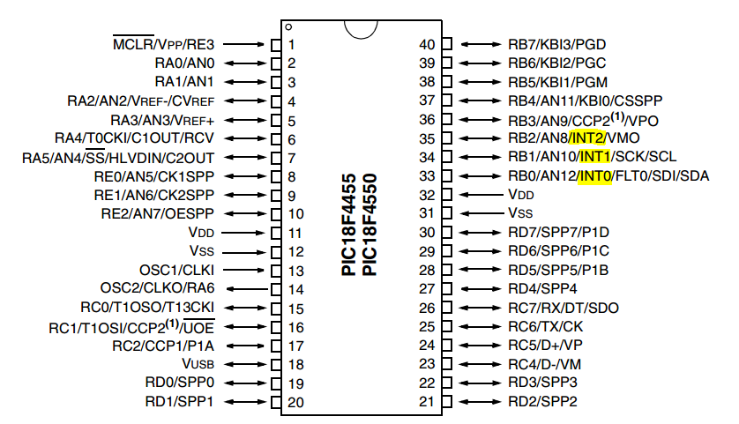

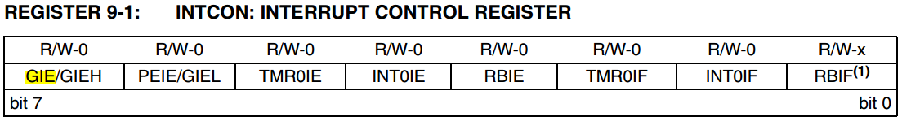

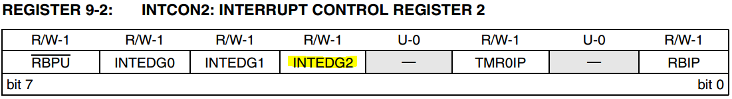

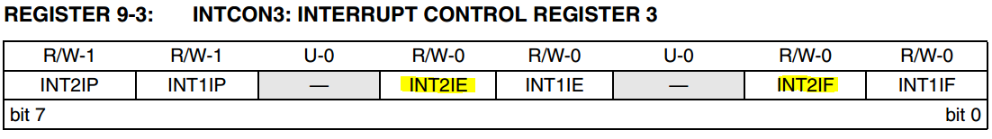

#include <xc.h> // general XC8 library
#define _XTAL_FREQ 48000000 // Brainbox Fun running at 48Mhz

void main(void) // main program
{
//alle these settings are well explained in the datasheet of the 18F4455
TRISD = 0x00; // make all 8 bits of PORTD output - LEDS
PORTD = 0x0F; // set 4 LSB's

// Settings to generate an interrupt at INT2(RB2) on rising edge
TRISBbits.RB2 = 1; // set RB2 as input
INTCON2bits.INTEDG2 = 1; // 1 = Interrupt on rising edge
INTCON3bits.INT2IE = 1; // 1 = Enables the INT2 external interrupt
INTCONbits.GIE = 1; // 1 = Enables all unmasked interrupts

while(1)
{ // never ending loop
// do nothing at all
}
}

void interrupt tc_int (void) // interrupt routine
{
INTCON3bits.INT2IF = 0; // 1 = The INT2 external interrupt occurred
//(must be cleared in software) - by making it 0
PORTD = PORTD^0b11111111; // flip all bits of PORTD (EXOR)
}

TIMER0 interrupt – 1 seconde

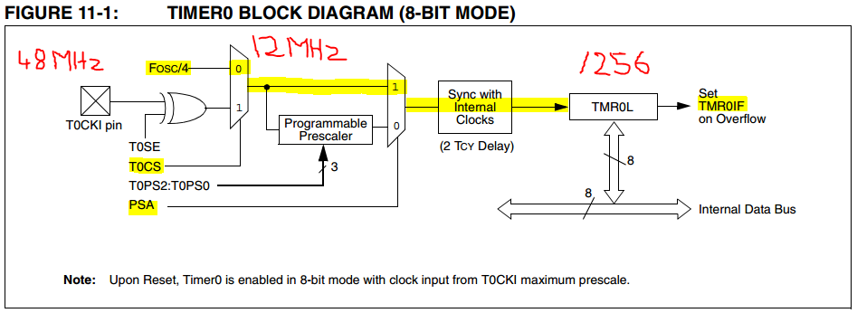

 | / | is | / | is | / | is
48000000 | 4 | 12000000 | 1 | 12000000 | 256 | 46875
48000000 | 4 | 12000000 | 2 | 6000000 | 256 | 23437,5
48000000 | 4 | 12000000 | 4 | 3000000 | 256 | 11718,75
48000000 | 4 | 12000000 | 8 | 1500000 | 256 | 5859,375
48000000 | 4 | 12000000 | 16 | 750000 | 256 | 2929,6875
48000000 | 4 | 12000000 | 32 | 375000 | 256 | 1464,84375
48000000 | 4 | 12000000 | 64 | 187500 | 256 | 732,421875
48000000 | 4 | 12000000 | 128 | 93750 | 256 | 366,2109375
48000000 | 4 | 12000000 | 256 | 46875 | 256 | 183,1054688

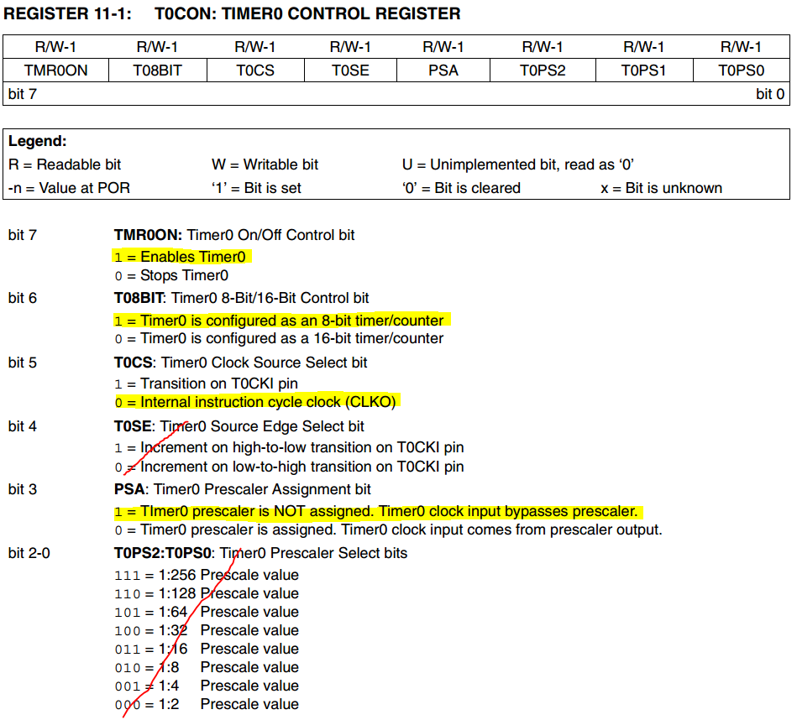

Dit programma gebruikt TIMER0 in 8 bit mode om exact elke seconde de toestand van de leds aan PORTD te veranderen. TMR0 staat zo ingesteld dat deze 46875 interrupt per seconde veroorzaakt.

#include <xc.h> // general XC8 library
#define _XTAL_FREQ 48000000 // Brainbox Fun running at 48Mhz

unsigned int secteller = 0; // 0-65535 - moet tot 46875 kunnen tellen

void main(void) // main program
{
//alle these settings are well explained in the datasheet of the 18F4455
TRISD = 0x00; // make all 8 bits of PORTD output - LEDS
PORTD = 0x0F; // set 4 LSB's

// Settings to generate an interrupt after 1sec using TMR0
T0CONbits.TMR0ON = 1; //1 = Enables Timer0
T0CONbits.T08BIT = 1; // 1 = Timer0 is configured as an 8-bit timer/counter
T0CONbits.T0CS = 0; // 0 = Internal instruction cycle clock (CLKO)
T0CONbits.PSA = 1; // 1 = Timer0 clock input bypasses prescaler

INTCONbits.T0IE = 1; // Enable interrupt on Timer0 overflow
INTCONbits.GIE = 1; // 1 = Enables all unmasked interrupts

while(1)
{ // never ending loop
// do nothing at all
}
}

void interrupt tc_int (void) // interrupt routine
{
INTCONbits.T0IF = 0; // int flag must be cleared in software

if (secteller >= 46875) // this is true - every second
{ // after 46875 ints - 1 sec is passed
PORTD = PORTD^0b11111111; // flip all bits of PORTD (EXOR)
secteller = 0; // reset secteller
}
else
{
secteller ++; // increment secteller
}
}

PWM – PULSE WIDTH MODULATION

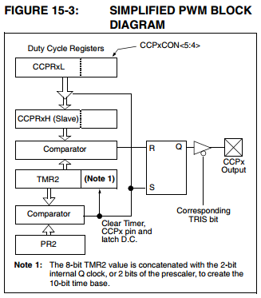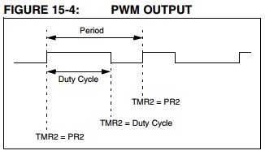
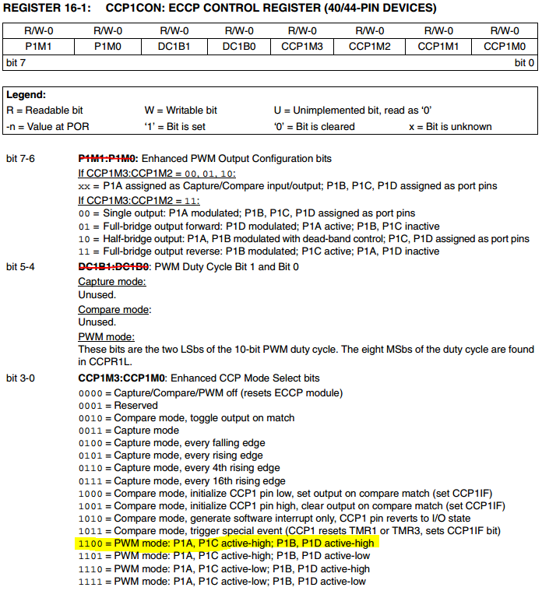

/*
* File: O-PWM
* Author: Bart Huyskens - www.e2cre8.be 04/2016
* HARDWARE: BRAINBOX FUN - PIC18F445 + Bootloader running at 48Mhz
*
* PWM signals are modulated at pins C1 and C2
* This program 'reads' the analog voltage at pin AN0
* The 8 bit result is displayed at the 8 leds of PORTD
* The same result is used to determine the Duty cycle at pin C2 and C1
*
*/
// PIC18F4455 Configuration Bit Settings -
// all config settings are made in the bootloader

#include <xc.h> // general XC8 library
#define _XTAL_FREQ 48000000 // Brainbox Fun running at 48Mhz

#define LEDARRAY PORTD // using a define to give pin a better name

void main(void) // main program
{
//alle these settings are well explained in the datasheet of the 18F4455
TRISD = 0x00; // make all 8 bits of PORTD output - LEDS

// PWM configuration
TRISCbits.RC2 = 0; // make pin output
TRISCbits.RC1 = 0; // make pin output

//config of CCP1 PWM pin (RC2)
CCP1CONbits.CCP1M3 = 1;
CCP1CONbits.CCP1M2 = 1;
CCP1CONbits.CCP1M1 = 0;
CCP1CONbits.CCP1M0 = 0; //11xx = PWM mode

//config of CCP2 PWM pin (RC1)
CCP2CONbits.CCP2M3 = 1;
CCP2CONbits.CCP2M2 = 1;
CCP2CONbits.CCP2M1 = 0;
CCP2CONbits.CCP2M0 = 0; //11xx = PWM mode

PR2 = 0xFF; // Full 10 bit resolution is possible

T2CONbits.T2CKPS1 = 1;
T2CONbits.T2CKPS0 = 0; // 10 = prescaler 16
T2CONbits.TMR2ON = 1; // activate TIMER 2 - TMR2 is used for PWM

// AD configuration
TRISAbits.RA0 = 1; // make pin INPUT pin
TRISAbits.RA1 = 1; // make pin INPUT pin
TRISAbits.RA2 = 1; // make pin INPUT pin
TRISAbits.RA3 = 1; // make pin INPUT pin

ADCON2bits.ADFM = 0; // 0 = Left justified -> 8 bit adc
ADCON2bits.ACQT2 = 1;
ADCON2bits.ACQT1 = 1;
ADCON2bits.ACQT0 = 1; // 111 = Aquisition time of 20 TAD - slowest
ADCON2bits.ADCS2 = 1;
ADCON2bits.ADCS2 = 1;
ADCON2bits.ADCS2 = 1; // FOSC/64 is necessary for our fast 48Mhz clock

ADCON1bits.VCFG1 = 0; // REF- = VSS
ADCON1bits.VCFG0 = 0; // REF+ = VDD
ADCON1bits.PCFG3 = 1;
ADCON1bits.PCFG2 = 0;
ADCON1bits.PCFG1 = 1;
ADCON1bits.PCFG0 = 1; //1011 makes pins AN0, AN1, AN2, AN3 all analog input pins
// all other AD pins are normal digital IO pins

ADCON0bits.CHS3 = 0;
ADCON0bits.CHS2 = 0;
ADCON0bits.CHS1 = 0;
ADCON0bits.CHS0 = 0; // 0000 = Select Channel AN0 for AD conversion
ADCON0bits.ADON = 1; // switch AD convertor on

while(1)
{ // never ending loop
ADCON0bits.GODONE = 1; // Start AD conversion
while (GODONE){} // wait for AD conversion to complete
LEDARRAY = ADRESH; // show 8 bit AD result on LEDS of portD

CCPR1L = ADRESH; // AD result determines PWM duty cycle of RC2
CCPR2L = 255 - ADRESH; // Inverse PWM duty cycle is sent to RC1
}
}

